1. Register User
Create a new user account in the system by completing the registration form.

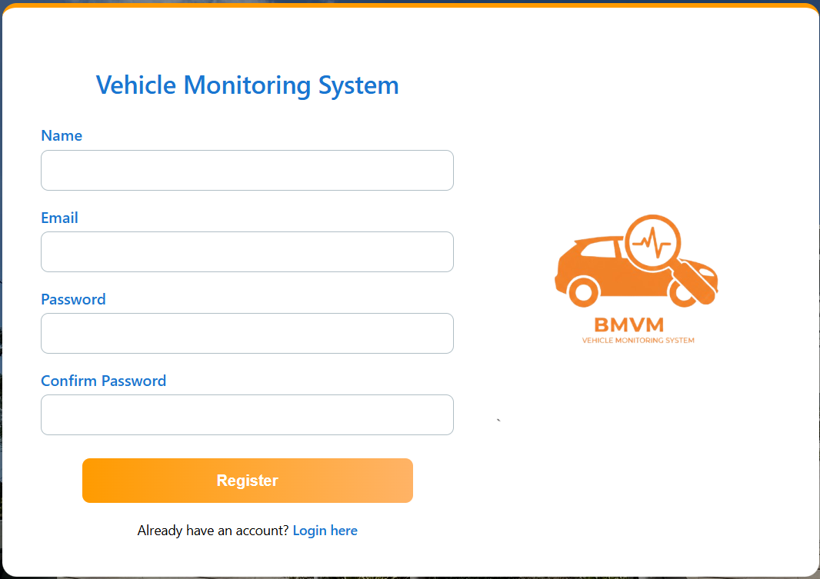

2. User Dashboard (After Registration)
After successful registration, the user dashboard will be displayed.
A message stating “No vehicle assigned to your account” will appear until a vehicle is assigned by the administrator.

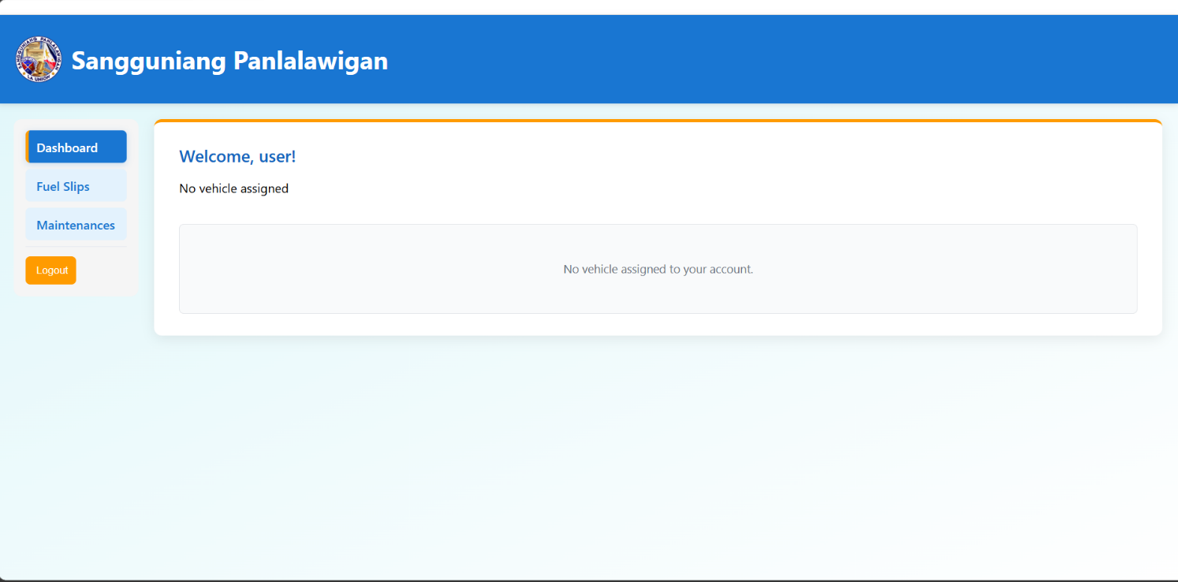

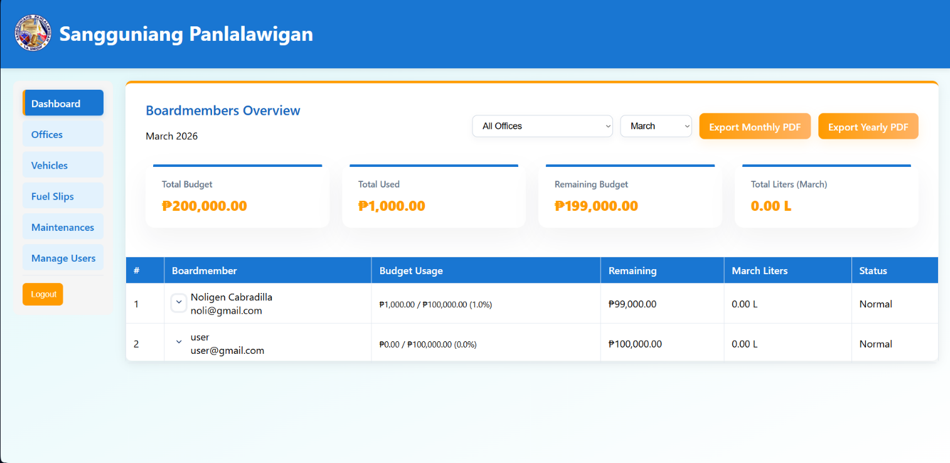
3. Admin Dashboard
The Admin Dashboard allows administrators to manage and monitor system data.
Administrators can:
- Export reports as Monthly PDF or Yearly PDF
- Filter offices to view specific records
- Monitor monthly budget expenses
Before proceeding, the administrator must assign the user to an office.

4. Assign User to an Office
- Click the Manage Users tab.
- Select the user.
- Assign the appropriate office.
- Save the changes.

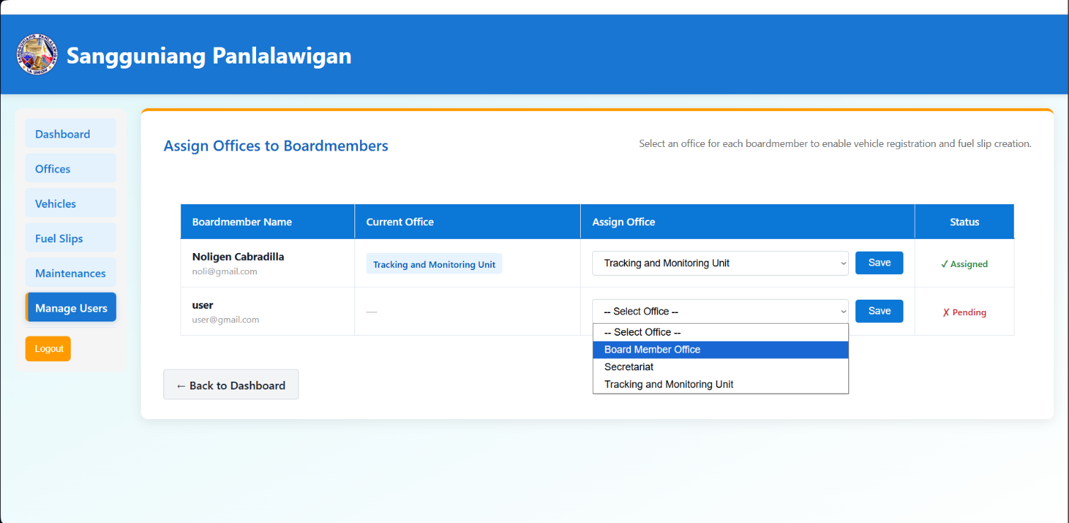

5. Register a Vehicle
To register a vehicle:
- Go to the Vehicles tab.
- Click Register Vehicle located at the upper-right corner.
- Fill in the required information:
  - Assigned User
  - Vehicle Name
  - Plate Number
  - Driver
- Submit the form.

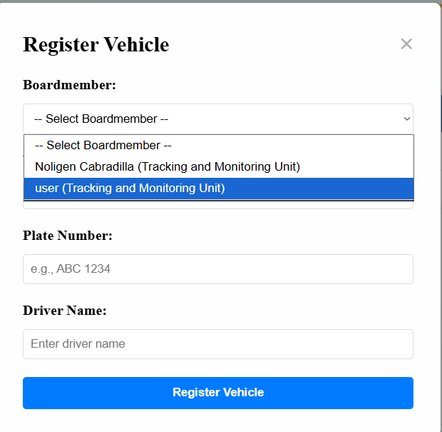
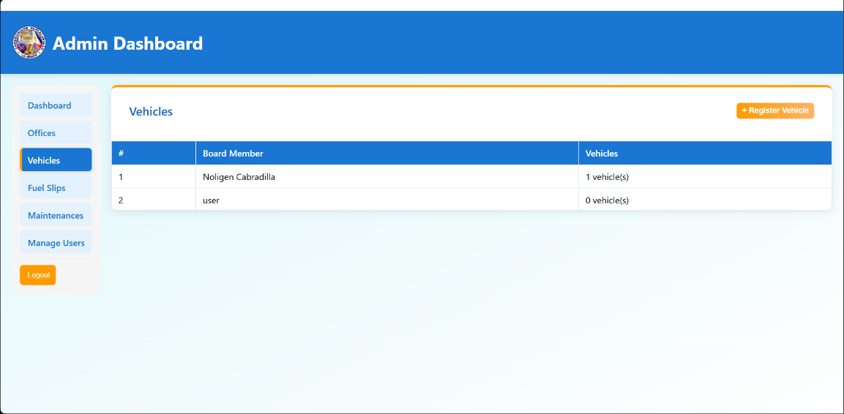

6. User Dashboard After Vehicle Assignment
Once the office and vehicle are assigned, the user dashboard will update automatically.
If no fuel records exist, the message “No fuel recorded for March” will be displayed.

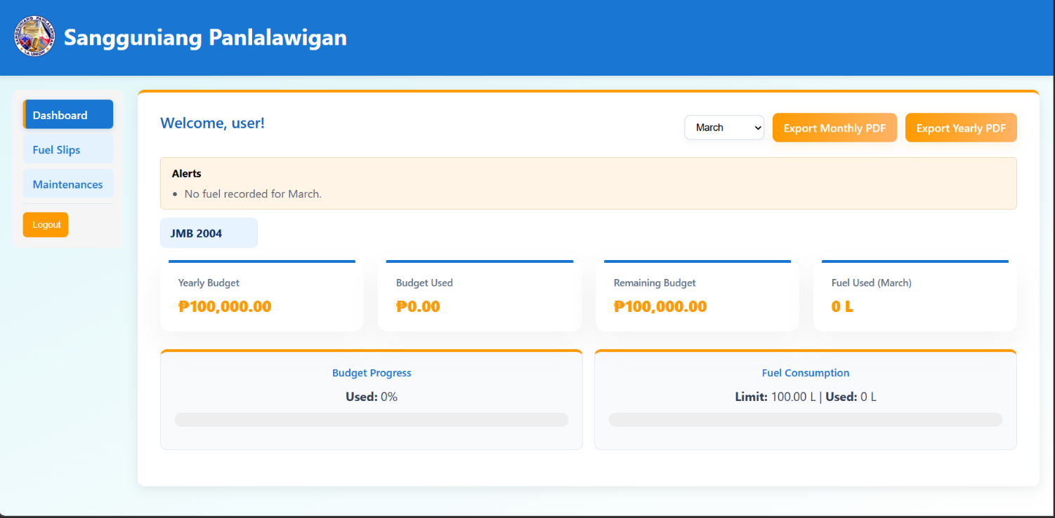

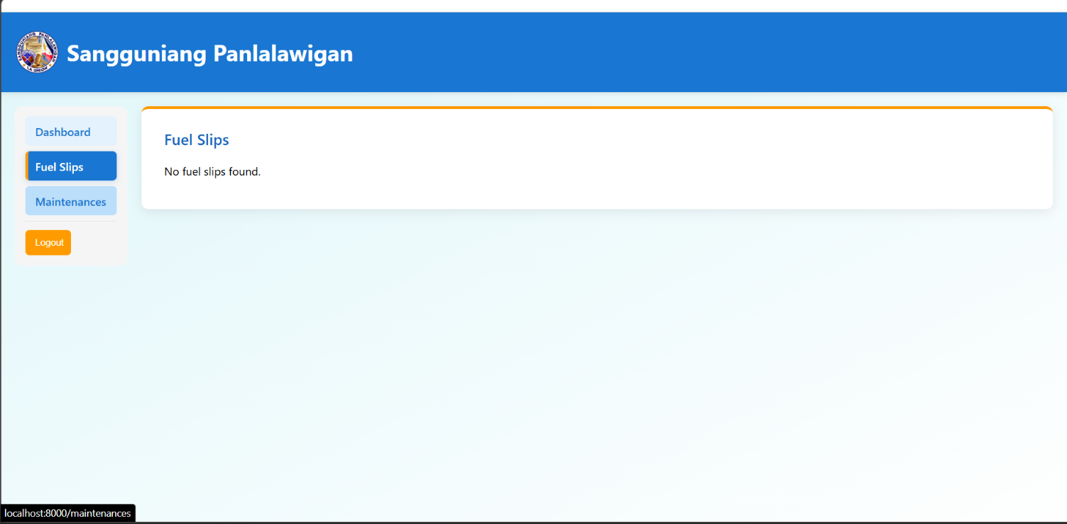
7. Fuel Slips and Maintenance Tabs
Initially, the Fuel Slips and Maintenance tabs will be empty.
Users must submit fuel slips or maintenance requests through the administrator before records appear.

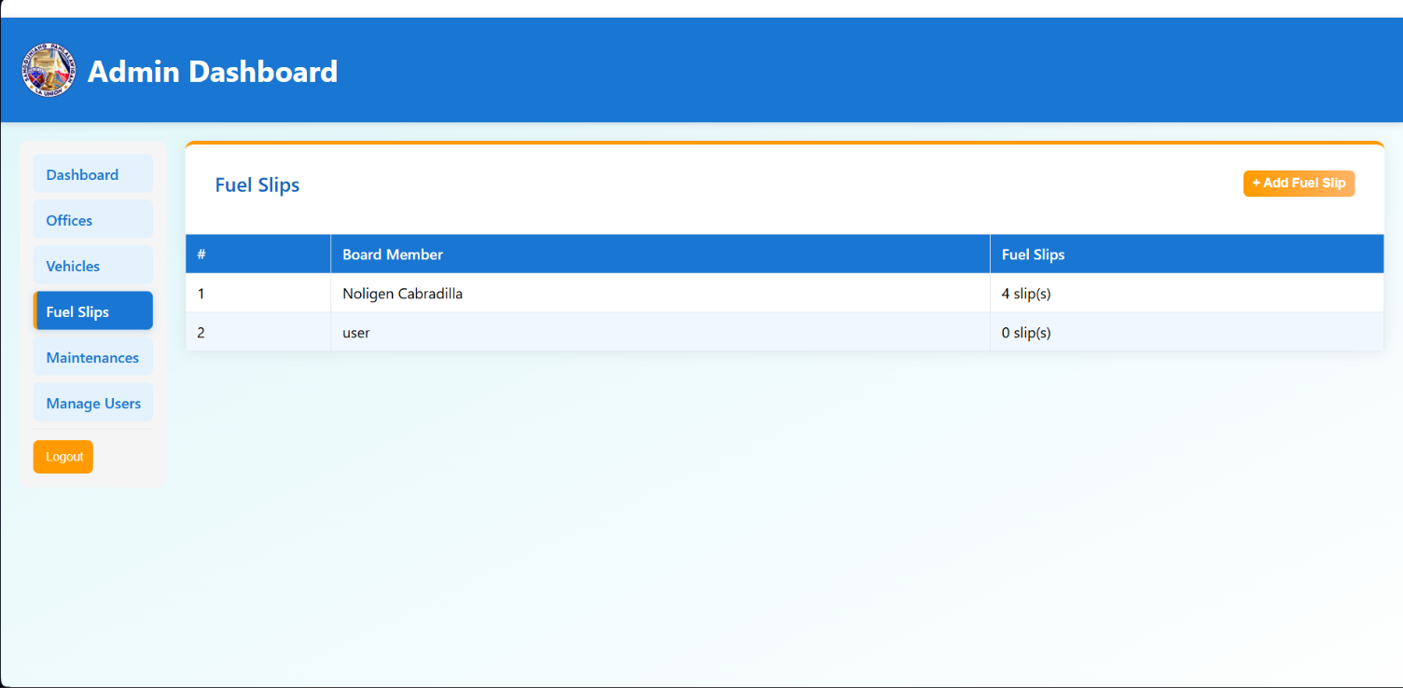
8. Adding a Fuel Slip
- Open the Fuel Slips tab.
- Click Add Fuel Slip at the upper-right corner.
- Create a new fuel record.

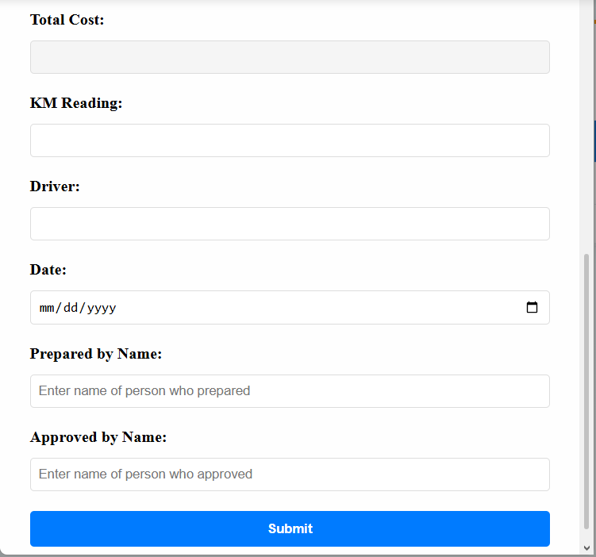
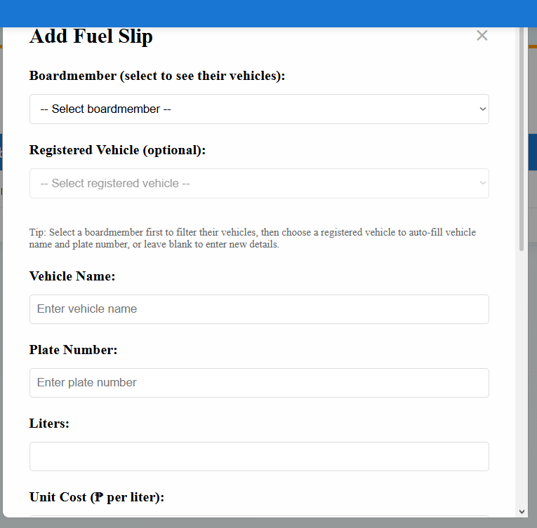
9. Fuel Slip Form
When adding a fuel slip:
- Select the assigned user.
- Complete all required fields.
- Submit the form to save the record.

10. Updated Dashboard
After adding fuel or maintenance records, both the Admin Dashboard and User Dashboard will display updated information.

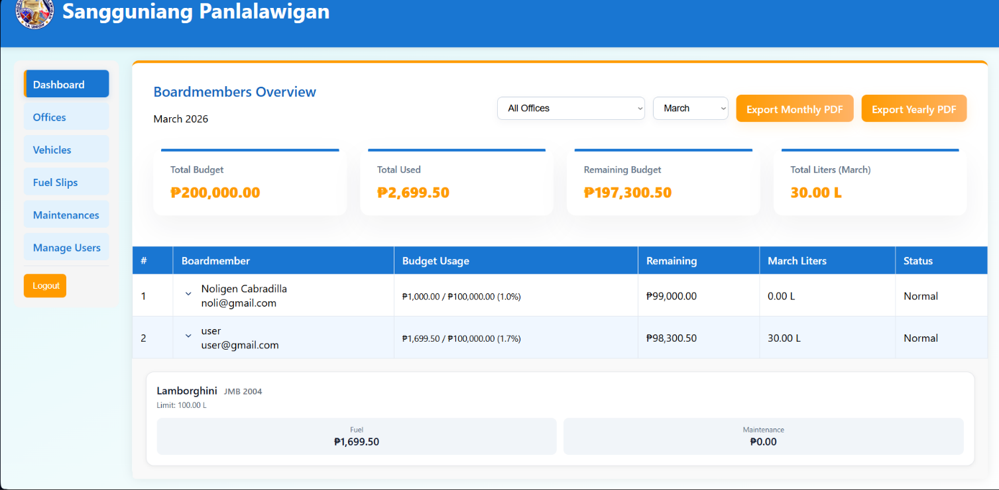
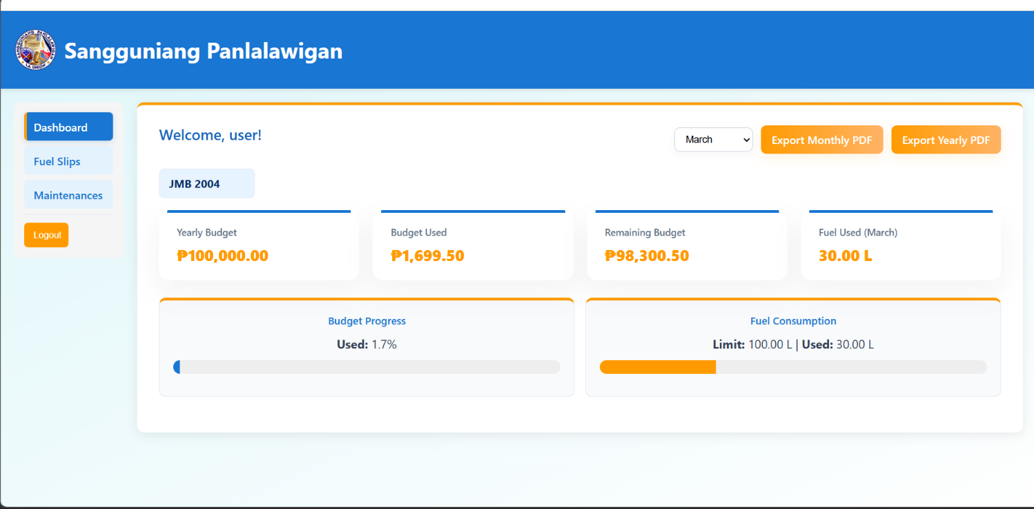
11. Maintenance Process
The maintenance process follows the same procedure as adding a fuel slip:
- Open the Maintenance tab.
- Add a new maintenance record.
- Complete and submit the form.

